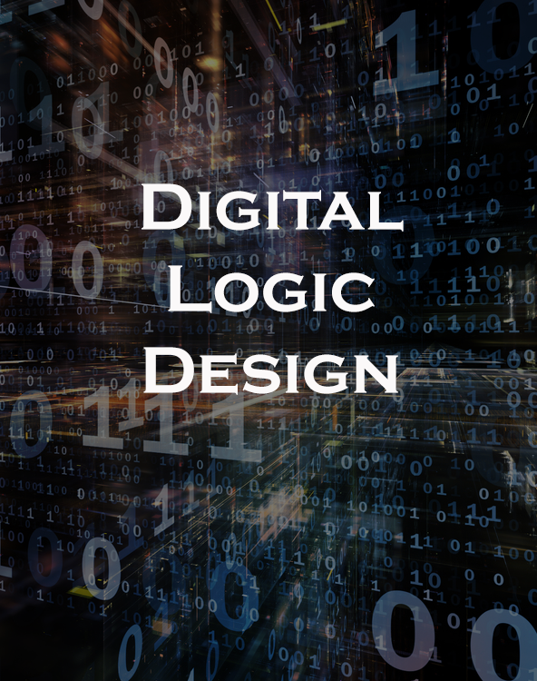

|  |
| --- |
| DLD PROJECT REPORT |

|  |  |  |
| --- | --- | --- |
| Group Members: |  |  |
|  | **Askari Hassan**: 19k1266  **M.Ebad**: 19k1420 | **Rooman Asif**: 19k0217  **Muaaz Amir**: 19k0215 |

TABLE OF CONTENTS

Introduction 3

Theory 3

Inspiration 3

Salient Features 3

Tools and Technology 3

Methodology 4

Circuit DIagram 5

Steps 5

Description 5

Working 5

Simulation 6

Video 6

# Introduction

## Theory

A Traffic Signal system is time based system which switches the LED lights from red to yellow and finally to green once the timer runs out. This project is basically 4 way straight line traffic control system.

This system will help in preventing accidents.

## Inspiration

Source project is a seminar project of students of UNIVERSITY OF AMERICA in Bangladesh. Meanwhile the inspiration is taken from the real world Traffic light system. Displaying commonly red (stop), yellow (ready) and green (go) for convenience.

## Salient Features

* + Changes signal (color of LED light) with respect to time.
  + Prevents U turns of traffic.
  + Control 4 different traffic ways at a time.
  + Speed of traffic signal can be adjusted according to need.

|  |
| --- |
| ***“Project has been shifted to a software based due to current circumstances.”*** |

## Tools and Technology

* + 555 timer IC (1).
  + 4017 Decade Counter (Johnson Counter) (1).
  + Traffic Signal LED. (3 in 1) (4) -> means 12 in total.
  + Software: Proteus 8.9 Professional.

# Methodology

Project will be judged on simulation bases, so the software we chose for this purpose is Proteus 8.9 Professional. Following is the procedure:

Think of a base model.

Choose and list all components.

Design a Circuit Diagram.

Run simulation on Proteus.

Proteus is a user friendly software super easy to use. Not to overshadow its usability, it is a powerful software for designing circuits.

|  |
| --- |
|  |

We created a project. Then worked on designing the circuit. After that we ran the simulation on Proteus.

# Circuit DIagram

## Steps

* Think of a base model.
* Choose and list all components.
* Design a Circuit Diagram.
* Run simulation on Proteus.

## Description

* Firstly, create rough image of circuit in your imagination. Then, use that as a blue print for the rest of the project.
* Creating a list of components that we were going to use and Search them in the search component panel in Proteus.
* After that, learn the use of 555 timer IC and design the circuit.
* Finally, run the simulation of the diagram.

## Working

This circuit works by a timer. At first, 555 timer IC take 5V DC as input and generate a clock for Decade counter which is connected to LED lights. We can change the rate at which counter increases its value, hence changing the rate at which LED lights changes its color.

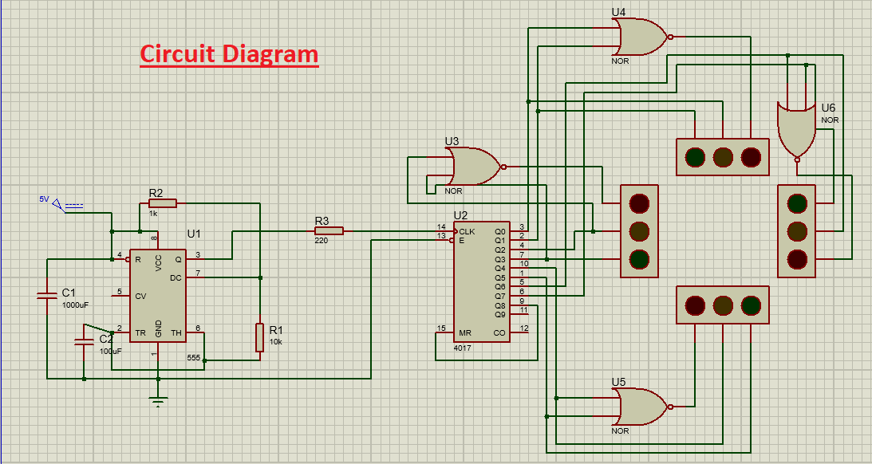

# Simulation

## Video

There is simulation video in this folder along this doc file…